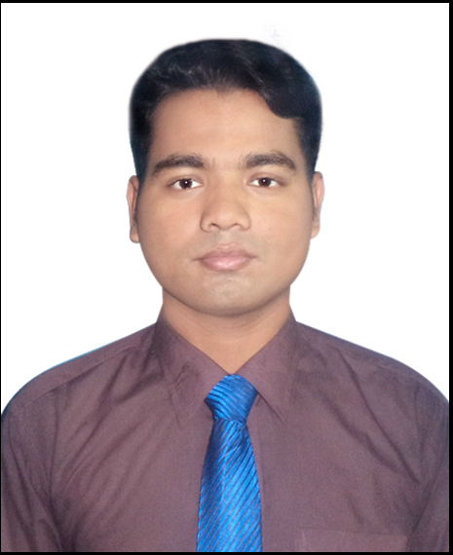
RESUME
OF
MD.JAKIRUL ISLAM

Kadim para,Bogra Shadar,Bogra.
Mobile:+8801717 22 04 72

OBJECTIVES :
Work in commercial environment where is an opportunity of self-assessment and Self-improvement in both individual business and corporate work that will ultimately lead from the further development of the common people.

EDUCATIONAL QUALIFICATION :

Masters Final (MSS)
University : National University.
Name of Institute : Govt.Azizul Haque College Bogra.
Result : 2nd Class(2.84 out of 4)
Passing year : 2018

Degree pass course (BSS)
University : National University.
Name of Institute : Govt.Azizul Haque College Bogra.
Result : 2nd Class(704 out of 780)
Passing year : 2013

Higher Secondary certificate (HSC)
Name of Institute : Thangga Mara College Bogra.
Group : Humanities
Education Board : Rajshahi
Year of passing : 2010
Result : 1.40(out of 5)
Secondary School Certificate (SSC)
School : Manik Chak High School Bogra.
Group : Science
Education Board : Rajshahi
Year of passing : 2007
Result : 2.69(out of 5)
EXPERIENCE :ORION PHAEMACEUTICALS MARKETING (MPO) 1 YEARS.
EXPERIENCE: SOUTH KOREA OF CERAGEM COMPANY HONORABLE TRAINER AND MANAGER (2) YEARS.
PERSONAL INFORMATION:

Name : Md. Jakirul Islam
Father’s Name : Md. Zamsed Ali
Mother’s Name : Mst.Mabia Bagum
Date of Birth : 09th October 1990
Marital status : Unmarried
Nationality : Bangladeshi (By Birth)
Height : 5 Feet 11 inches
Blood Group : o (+) Ve

CONTACT ADDRESS :

Permanent Address : Vill :Kadim para,
P.O : Pollimongal Hat,
Thana : Bogra Shadar,
Dist : Bogra

Contact Number : +8801717 22 04 72

LANGUAGE SKILL :

Bangali - Mother Tongue.
English – Good skilled in both reading, writing & speaking.

COMPUTER SKILL :
Desktop Management with Ms-office,Ms word, Excel, Photosop,E-mail,Internet, Browsing. Etc.

I confirm that to best of my Knowledge the information given herewith is true, authentic and up-to date.

Signature

Date :……../………../……..

